REPORT

NAME : SANSKRUTI NAWANDER

1. INTRODUCTION
The Conversational Insights Generator is an AI-powered system designed to analyze customer debt-collection call transcripts.
It uses Google’s Gemini LLM to extract structured insights such as customer intent, sentiment, follow-up requirements and a summary. The backend is implemented using FastAPI, PostgreSQL (async), and Pydantic.
The entire solution is consolidated into a single-file API (assignment.py) as per assignment requirements.
2. PROBLEM STATEMENT
Debt-collection agencies process thousands of customer-agent call transcripts daily.
Manual review is slow, inconsistent, and resource-heavy. The goal is to automate transcript analysis using LLMs to obtain:
• Customer Intent
• Sentiment
• Action Required
• Summary
3. OBJECTIVES
• Build a single-file FastAPI pipeline.
• Use Gemini 2.0 Flash Lite for structured insight extraction.
• Validate input using Pydantic.
• Store insights in PostgreSQL.
• Provide REST endpoint for real-time analysis.
• Process 10 sample transcripts and export the results to CSV.
4. SYSTEM ARCHITECTURE
The system combines FastAPI, Gemini, PostgreSQL, and async programming.
5. WORKFLOW DIAGRAM
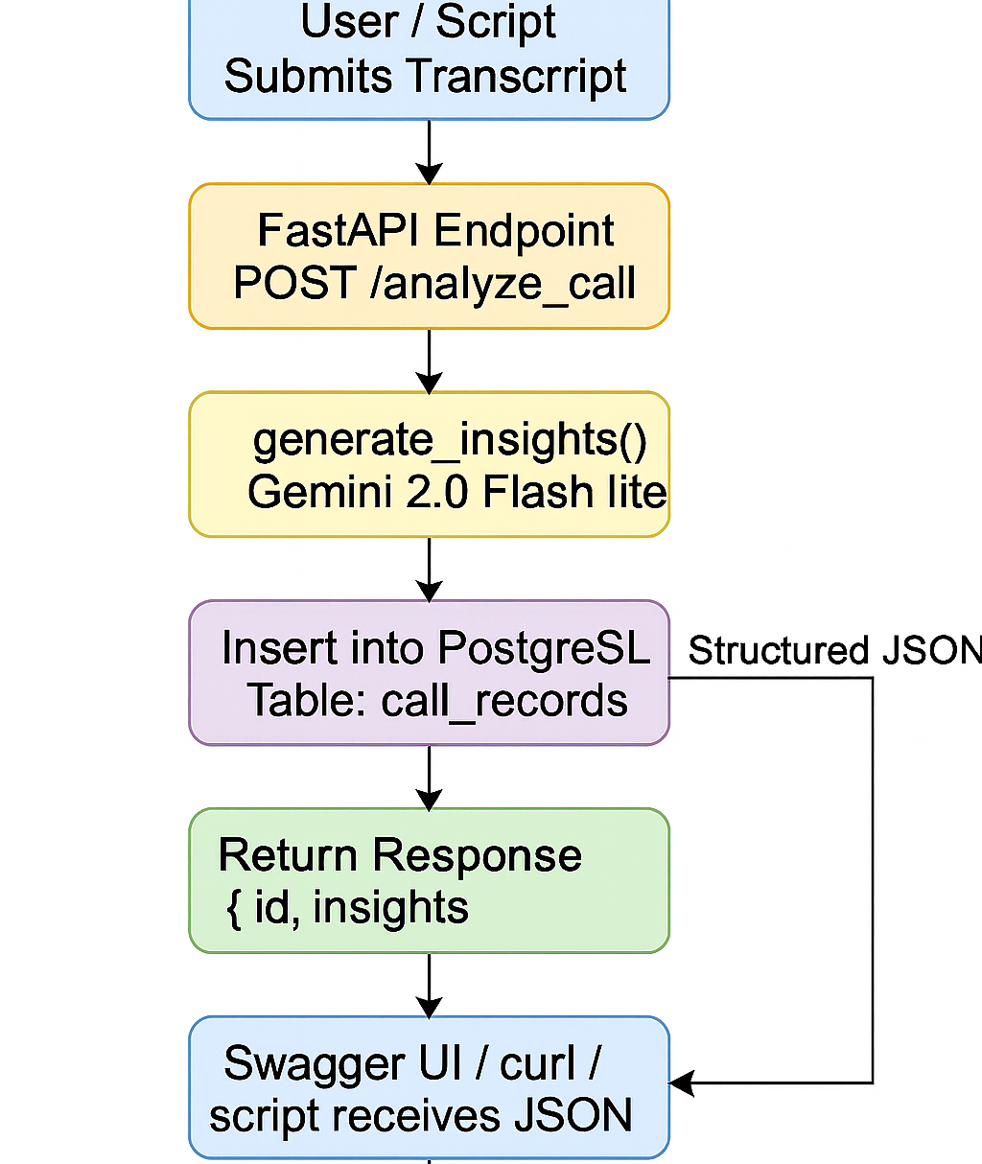
6. TECHNICAL IMPLEMENTATION
6.1 FastAPI Endpoint
Endpoint: POST /analyze_call
Accepts transcript → validates input → calls Gemini → stores in DB → returns insights.
6.2 Pydantic Models
Two models:
• TranscriptIn – validates incoming request
• CallInsight – schema for LLM structured output

6.3 Gemini LLM Extraction
Gemini is invoked with a strict JSON schema using response_schema=CallInsight for deterministic output.
6.4 Database Schema
A single table:
id, transcript, intent, sentiment, action_required, summary, created_at
6.5 Execution Flow
1. Setup PostgreSQL
2. Create .env
3. Install dependencies
4. Run API
5. Test with Swagger
6. Process sample transcripts
7. Verify DB
8. Export CSV
7. RESULTS
• All transcripts processed successfully
• Insights saved in PostgreSQL
• CSV exported (call_records_insights_samples.csv)
• Full pipeline working end-to-end
8. CONCLUSION
The project successfully demonstrates automated insight extraction using LLMs.
The pipeline is scalable, cleanly architected, and ready for production-level enhancement.

